16×2 LCD

GENERAL DESCRIPTION

LCD stands for liquid crystal display. They come in many sizes 8x1 , 8x2 , 10x2 , 16x1 , 16x2 , 16x4 , 20x2 , 20x4 ,24x2 , 30x2 , 32x2 , 40x2 etc . Many multinational companies like Philips Hitachi Panasonic make their own special kind of LCD'S to be used in their products. All the LCD'S performs the same functions (display characters numbers special characters ASCII characters etc).Their programming is also same and they all have same 14 pins (0-13) or 16 pins (0 to 15). Alphanumeric displays are used in a wide range of applications, including palmtop computers, word processors, photocopiers, point of sale terminals, medical instruments, cellular phones, etc.

PRODUCT DESCRIPTION

This is an LCD Display designed for E-blocks. It is a 16 character, 2-line alphanumeric LCD display connected to a single 9-way D-type connector. This allows the device to be connected to most E-Block I/O ports. The LCD display requires data in a serial format, which is detailed in the user guide below. The display also requires a 5V power supply. Please take care not to exceed 5V, as this will cause damage to the device. The 5V is best generated from the E-blocks Multi programmer or a 5V fixed regulated power supply.

The 16 x 2 intelligent alphanumeric dot matrix displays is capable of displaying 224 different characters and symbols. A full list of the characters and symbols is printed on pages 7/8 (note these symbols can vary between brand of

LCD used). This booklet provides all the technical specifications for connecting the unit, which requires a single power supply (+5V).
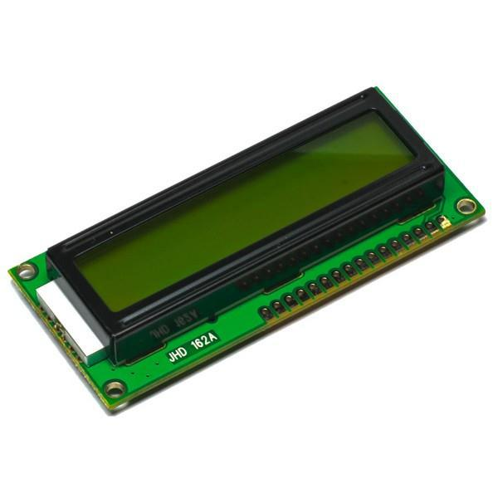

16x2 LCD

FEATURES

- Input voltage: 5v

- E-blocks compatible

- Low cost

- Compatible with most I/O ports in the E-Block range

- Ease to develop programming code using Flow code icons

APPLICATIONS

- Monitoring

